Environment preparation

1. Install pycharm

(1) Official website https://www.jetbrains.com/pycharm/

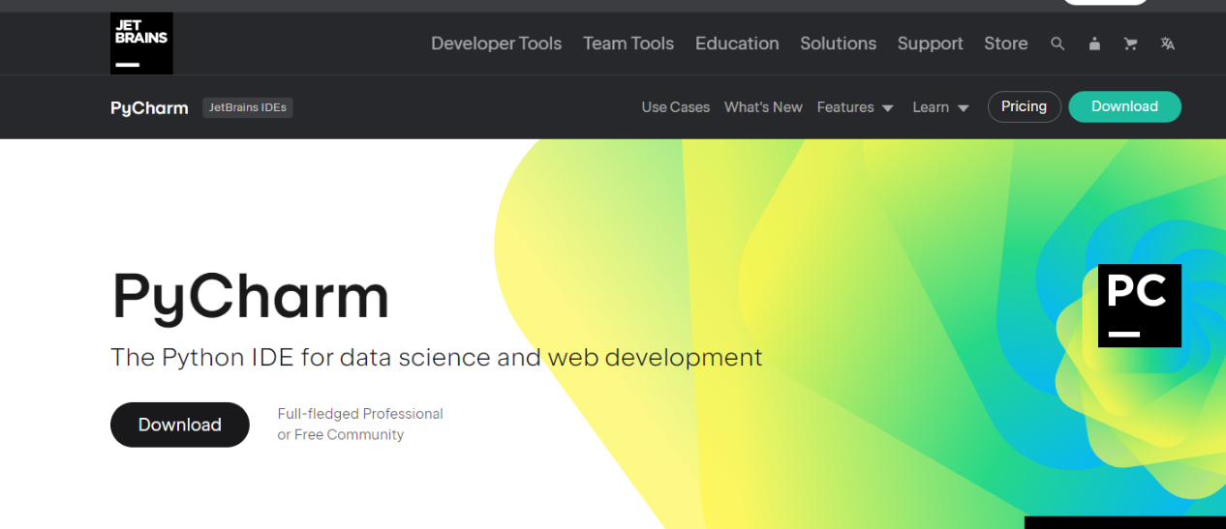

(2) Then come to this interface and click the Download button.

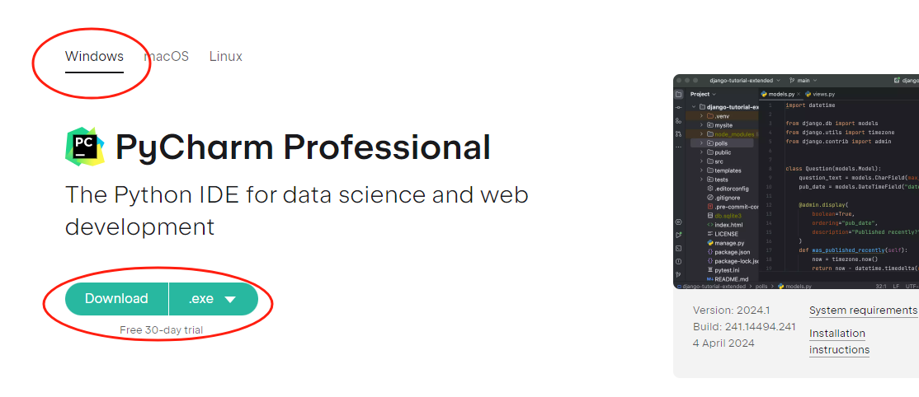

(3) Click Install, modify the installation path, it is recommended to install a location other than the C drive (convenient for finding program files), after modifying, click Next.

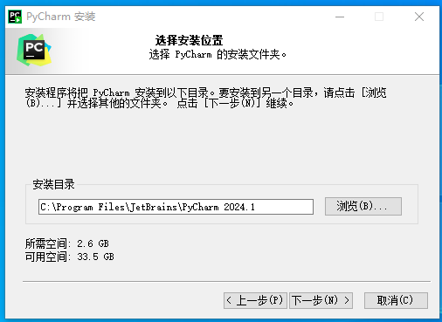

(4) CHECK ALL OF THEM, IF THERE ARE JAVA EDITORS AND OTHER EDITORS, IT IS NOT RECOMMENDED TO CHOOSEpy option, which is the associated file.

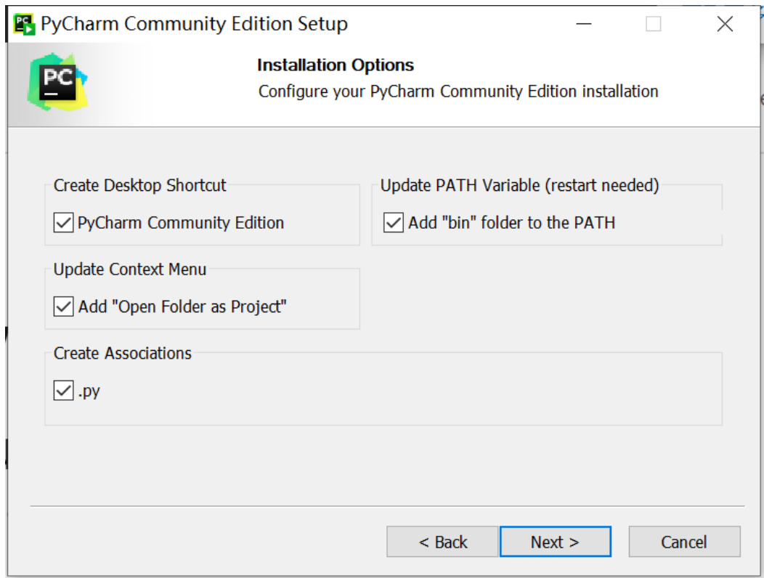

(5) Next, click Install, and the installation interface will appear until the installation is completed.

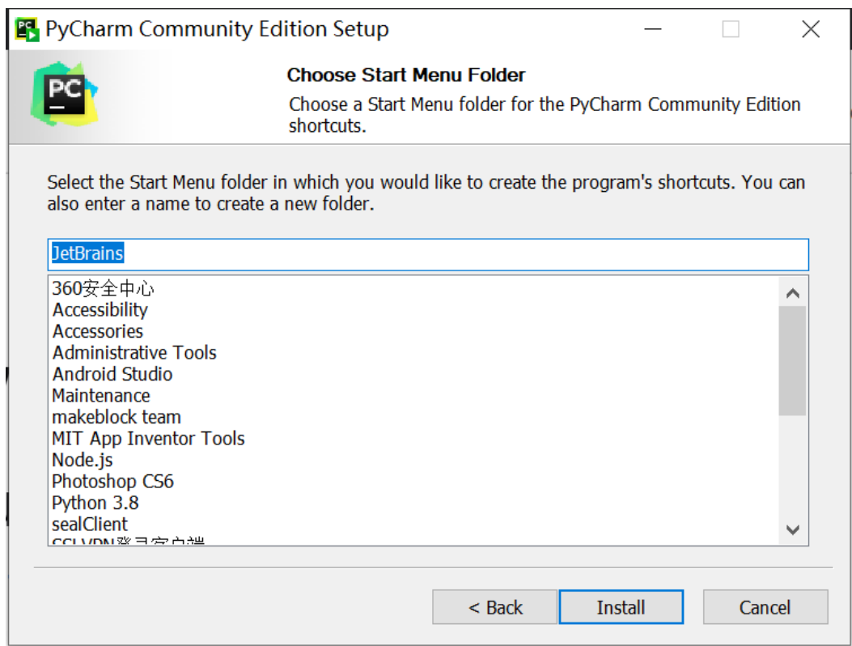

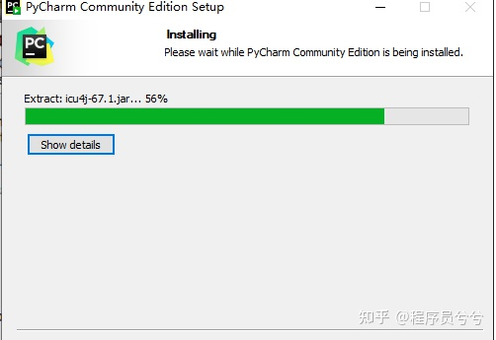

2. Install the python environment

(1) If you haven't downloaded the Python interpreter before, you need to download the python interpreter, otherwise pycharm will be lonely and difficult to sound. Go to the official website of Python: [https://www.python.org/](https://link.zhihu.com/?target=https://www.python.org/).

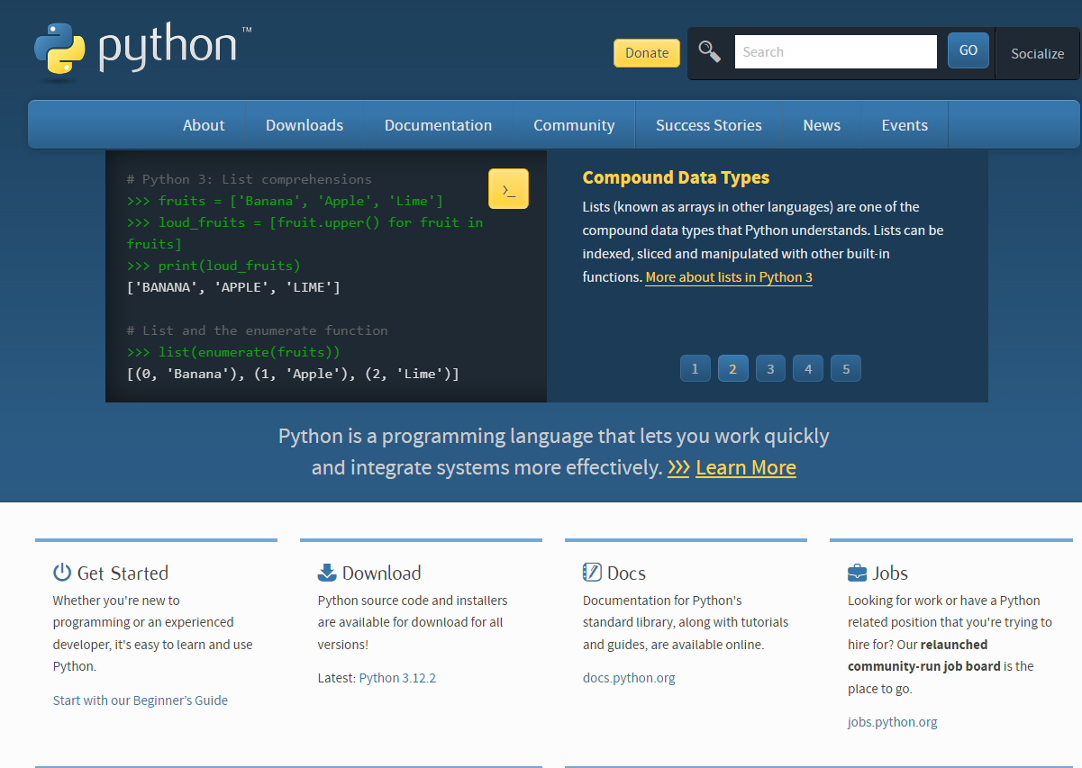

(2) As shown in the figure below, move to Download, and the drop-down option that appears selects the windows version, and then downloads python.

Note: (1) Windows x86-64 represents the 64-bit windows operating system;

(2) Windows x86 means 32-bit windows operating system;

(3) web-based install means online installation, downloading is an executable program, after double-clicking, the program automatically downloads the installation file for installation, because it is online installation, there must be a network;

(4) executable install means program installation, download is an exe executable program, open and install;

(5) The zip in the embeddable zip file is not very familiar, so the surface download is a compressed file, and the installation is completed after decompression.

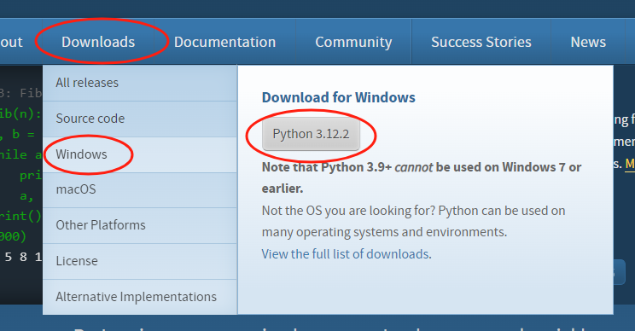

(3) After the download is successful, find the path of the Python installation package and open the installation package.

（4）打开我们首先勾选Add Python3.8 to PATH，然后点击install Now。

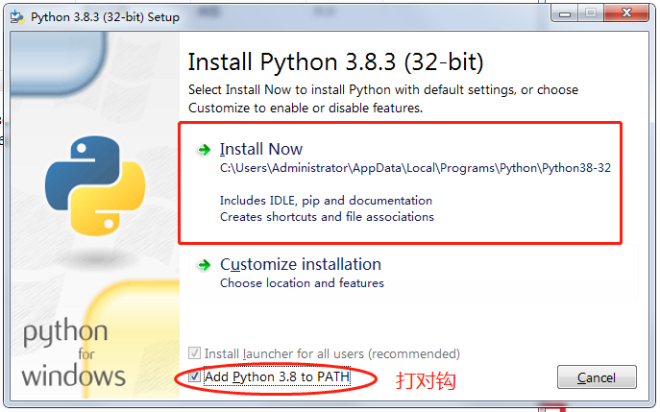

(5) Start the installation

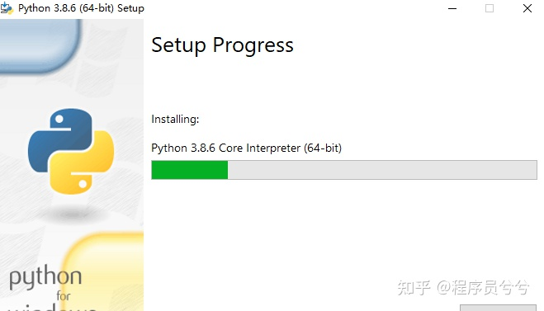

(6) After the installation is successful, click close, and the python installation is completed.

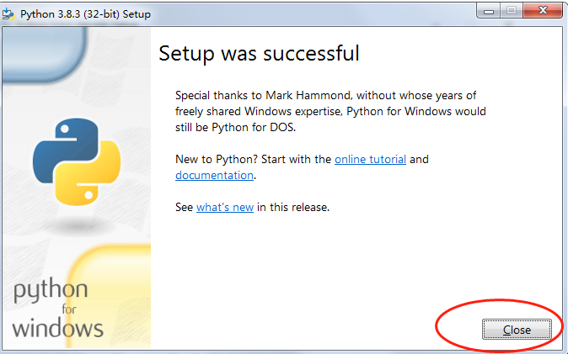

(7) Check the environment variable configuration: (this step can be skipped).

Open the win key + r, pop up the run box, enter cmd, and open the cmd command line window. If you can enter python and press Enter, if you can enter the command line window of python, it means that the Python environment variable is successfully configured.

At this point, the Python 3.8.6 installation is complete

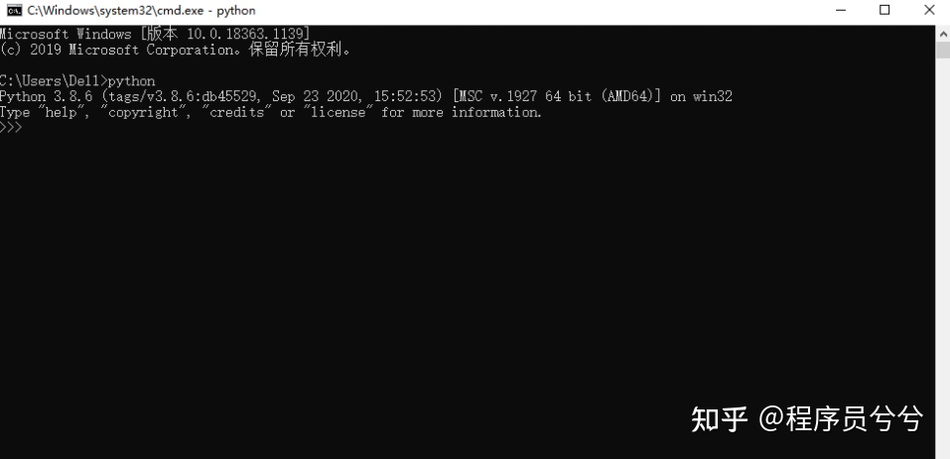

(8) Install the python library file, enter the folder shift+right-click to bring up "open command window here". Type python setup.py install in the command box and press Enter to install our library.

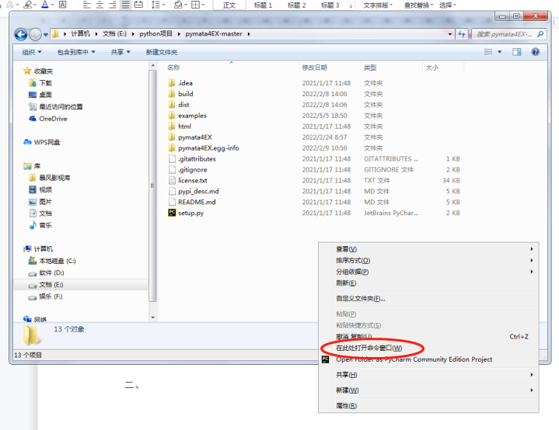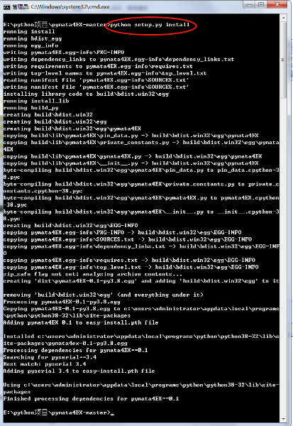

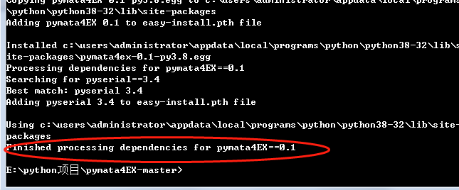

3、Arduino IDE安装

(1) Enter the official website www.arduino.cc complete the installation package download.

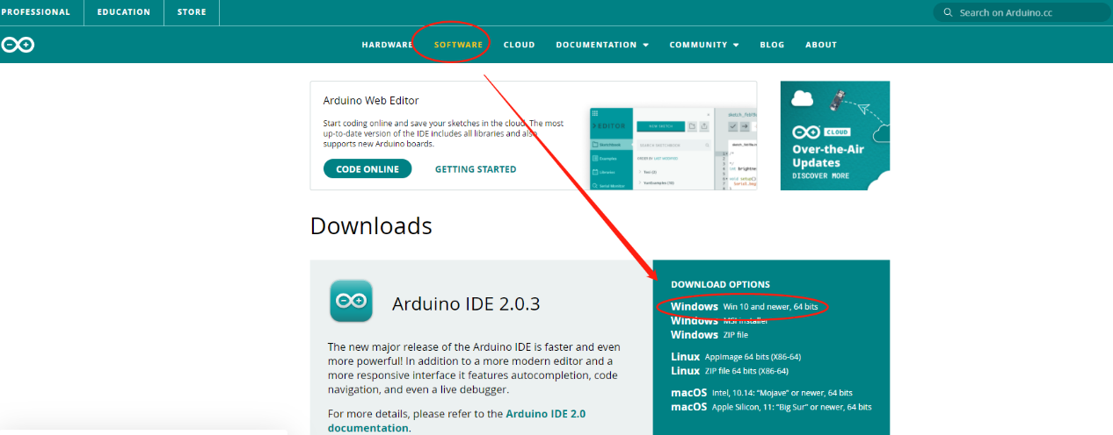

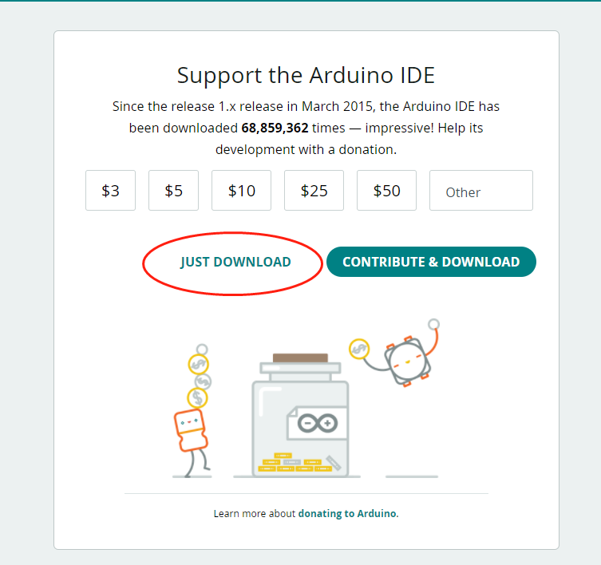

1. 安装Arduino IDE

Double-click and press the subpackage to install the software, and the installation is completed as shown in the following figure.

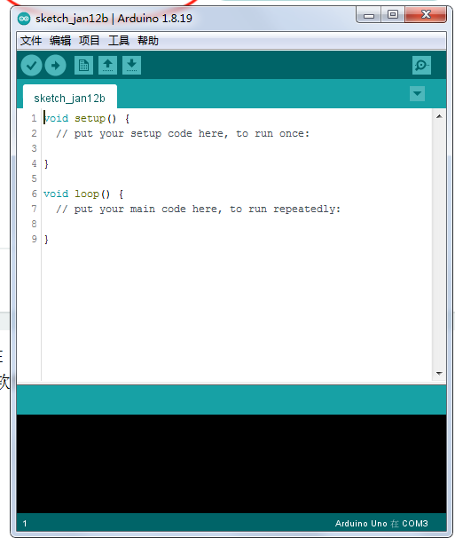

1. To install the IDE library, click on "Tools" --- "Library Management", and enter our library file name Firmataexpress to install it. Note that we chose to install version 1.2.0. Select Install All to install.

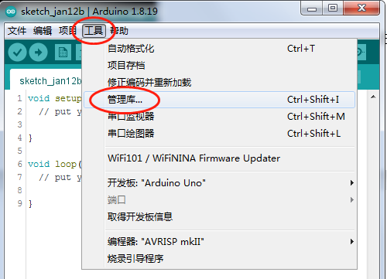

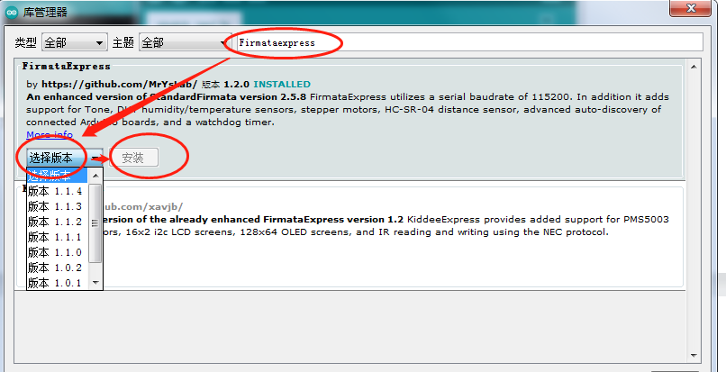

1. Hardware uploads the Firmataexpress library file

After the library installation is completed, we click on "File" ---- select "Example", find the third-party library sample, and then find our library file and open it. After opening the library file, we checked our practice box to our computer. Click "Tools" --- "Development Type" and select arduino UNO, and select comX as the port. Click1673509867625 the button to upload the library file.

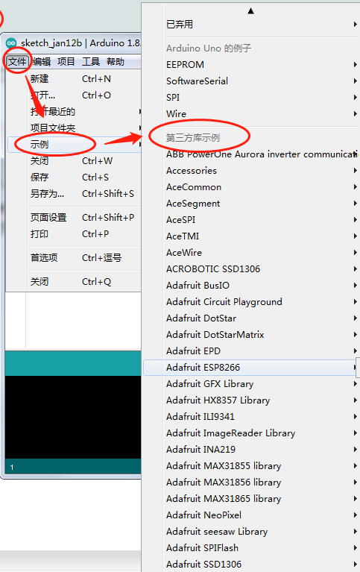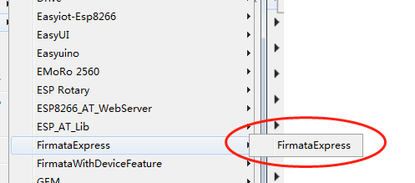

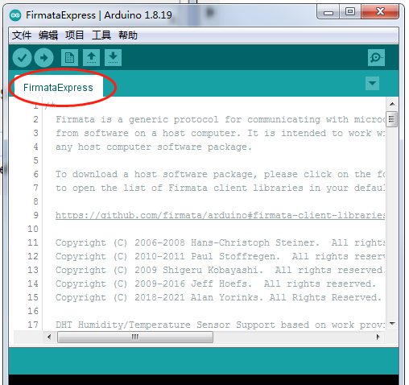

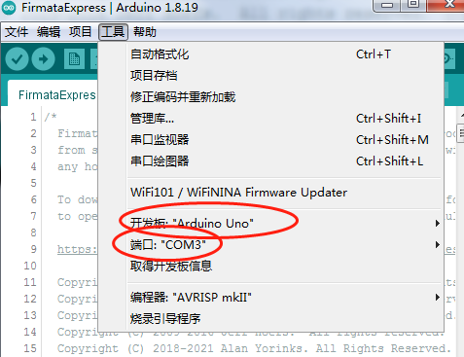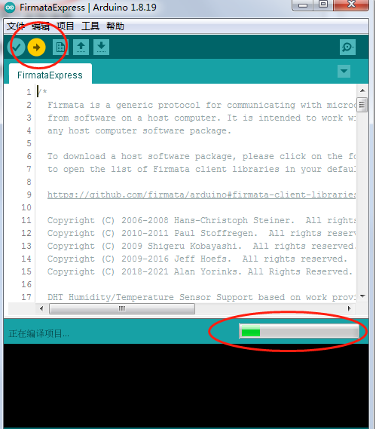

1. The basic syntax of Python

1. Grammar

(1) print output

The default output of print is a line break, separated by a comma between different data, and the output of a line break:\n.

(2) Python annotations

单行注释:# ctrl+/

Multi-line comment: '''' '

(3) Numerical value

It is the same as the numeric value in the number (note: the value is not in quotation marks).

(4) Strings

Python uses quotation marks to denote strings (a string of literals).

(5) Variables

What is a variable: In a programming language, a piece of data is stored and needs to be received with a variable.

Naming convention for variables: Variable Type Variable Name = Value

Including numbers, letters, underscores, not starting with numbers, try to know the name.

Note: No keywords.

int age = 18

(6) Identifier: (All the names we take are identifiers)

Specification: Identifiers are composed of letters, numbers, and underscores, and keywords cannot be used.

Identifiers include: variable name, function name, class name, module name, and project name.

In Python, all identifiers can include letters, digits, and underscores, but cannot start with digits.

Identifiers in python are case-sensitive, and uppercase A is not the same as lowercase A.

(7)input:

input fetches a data from the console, and the obtained type is a string type.

2. Circulation

Several common cycles, which end in for... in..., while, and range() are the most common

There will be a lot of things that can be done in the cycle, you can do multiple rounds of addition, subtraction, multiplication, arithmetic, fibona, and so on.

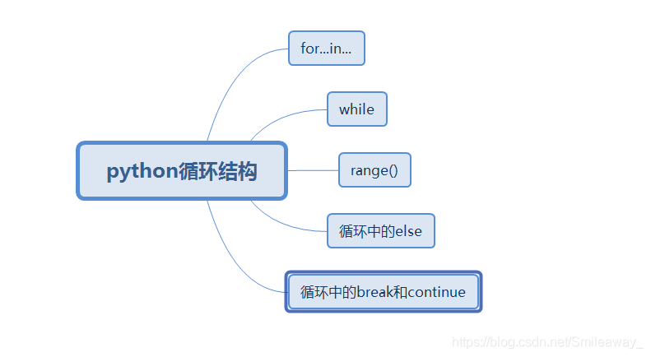

1. for… in…      #range

Generally, it is used with () for a certain interval, format: for parameter in loop: #这一种就是把所有的都打印一次

Enter str_01 = 'What to eat today' for i in str_01:

print(i)

The output is  
 what  
 to   
eat   
today

（2）while

This loop is a conditional loop statement, which means that a certain program will be executed when the conditions are met, and then the same operation will be repeated all the time. in... The difference with loops is that while needs to initialize the loop variable first or use the dead loop form of while True

①

格式：i = 0while i >=10:pass  
i +=1

②

格式：while True:pass

(3) In this case, add a break, and the loop will stop when a certain value is reached. It is also possible to skip this loop with continue

i = 0while i<10:  
i+=1if i==5: #当i=5时,结束整个循环breakprint("i=%d"%i)

**Python uses indentation to distinguish between different blocks of code, so there are strict requirements for indentation.**

1. If the indentation does not meet the rules, the parser will report an indentation error, and the program cannot be run.

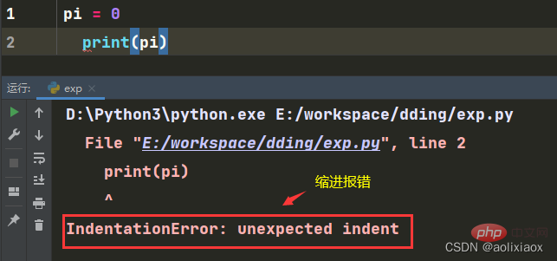

2. The effect of program execution may also be different depending on the indentation.

For example, in the code in the figure, the second line of the code on the left will be printed, while the second line of the code on the right will not be printed

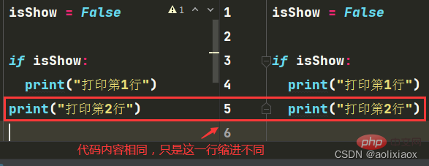

## 1. Code indentation rules

**Indentation is for logical lines, so first distinguish between physical and logical lines in your code.**

Physical Lines: The code displayed in the code editor, each of which is a physical line.

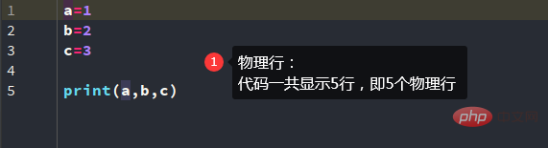

**Logical line: The Python interpreter interprets the code, and a statement is a logical line.**

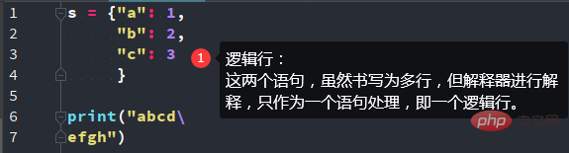

python code

1. You can use ";".to merge multiple logical lines into a single physical line.

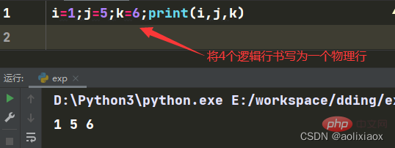

The premise here is that multiple lines of logic should belong to the same code hierarchy.

A branch else block like this can't just use ";" connected.

2. You can use "\" to wrap a logical line and write it as multiple physical lines.

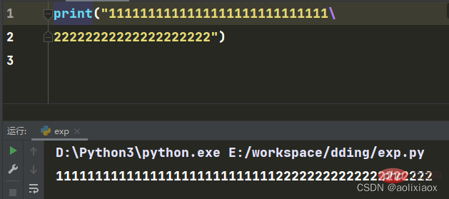

3. Variable assignment statements such as dictionaries and lists can be directly wrapped and written as multiple physical lines.

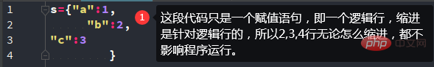

**Indentation rules**

### 1. The "first line" of the logic line needs to be topped, that is, there is no indentation (that is, the first logical line of a source code)

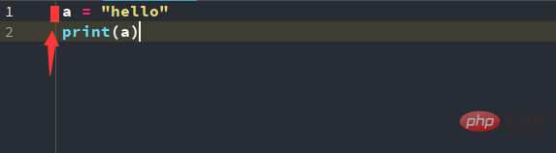

### 2. The same logical layer (the same code block) maintains the same indentation

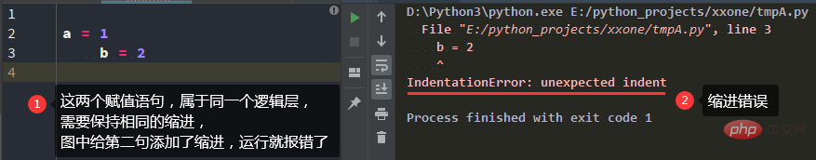

### 3. ":" marks a new logical layer

Such as: while loops, if branches, function declarations, class definitions, etc

#### Increasing the indentation indicates moving to the next layer of code

#### Decreasing the indentation means returning to the previous code layer

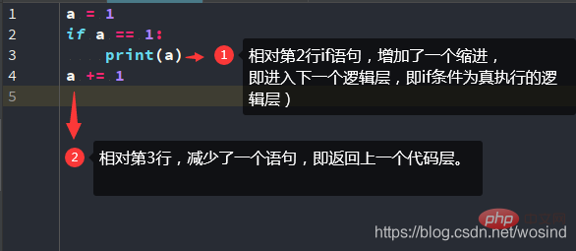

## 2. Indentation and indented characters

**Python can mark indentation using spaces or tabs. There is no limit to the number of indentations (number of characters).**

However, spaces and tabs are usually displayed in the form of blanks, which is not easy to distinguish between them, which affects code reading and increases the difficulty of maintenance and debugging. Therefore, the Python PEP8 encoding specification guides the use of 4 spaces as indentation.